Software Requirements

Specification

For

BotBots

Version 1.0

Prepared by

630615021 NUTTAPONG INKAEO

640615011 CHAYUT RIANPRAKAISANG

640615012 CHINNAWAT SERMSUKRUNGSAKUN

640615013 NATAKORN THAMMATIWAT

640615019 PARIPAT YUANSEE

640615504 HANCHUN WANG

# Table Of Content

Contents

Table Of Content 2

Revision History 3

1. Introduction 4

1.1 Purpose 4

1.2 Document Conventions 4

1.3 Scope of the system 4

1.4 Overview 4

1.5 References 4

2. Overall Description 5

2.1 Product Perspective 5

2.2 Product Functions 6

2.3 User Classes and Characteristics 6

2.4 Constraints 7

2.5 Assumptions and Dependencies 7

2.6 Apportioning of Requirements 7

3. Specific Requirements 8

3.1 External Interfaces 8

3.2 Functions 8

3.3 Performance Requirements 8

3.4 Logical Database Requirement 8

3.5 Design Constraints 8

3.6 Software System Attributes 8

3.7 Requirements Organization 9

4. Appendix 11

4.1 Appendix A: Glossary 11

4.2 Appendix B: Analysis Models 12

4.3 Appendix C: To Be Determined List 13

4.4 A1 - Responsibility 14

4.5 A2 - Responsibility percentage calculation 15

# Revision History

|  |  |  |  |
| --- | --- | --- | --- |
| **Name** | **Date** | **Reason For Changes** | **Version** |
| Paripat | 29 June 2023 | Customize for the client’s requests | 1.0 |
| Paripat | 12 July 2023 | Complete proposal letter | 1.1 |
| Paripat | 24 July 2023 | Upload Initial version of web (Main Page) | 1.2 |
| Chin, Great | 27 July 2023 | Update UI | 1.3 |

# Introduction

## 1.1 Purpose

The purpose of the BotBots is to automated and interactive communication with users. The website will help CPE and ISNE students answer questions that they cannot deal with it.

## 1.2 Document Conventions

Outline any specific conventions used in this document, such as formatting styles, naming conventions, or symbols.

## 1.3 Scope of the system

The project aims to help CPE and ISNE or other students that need to ask their own questions.

## 1.4 Overview

The implementation of BotBots as an intelligent chatbot for the Department of Computer Engineering offers a comprehensive solution to the identified problems. Its ability to automate query handling, provide up-to-date information, deliver personalized experiences, and contribute valuable insights will significantly improve the efficiency and effectiveness of the department's communication processes, benefitting stakeholders and enhancing the overall user experience.

## 1.5 References

Chat GPT- <https://chat.openai.com/>

CPE111 - Internet and Online Community Facebook pages <https://www.facebook.com/CPE111/>

# Overall Description

## 2.1 Product Perspective

a) System Interfaces:

BotBots is designed as a standalone system, and it does not directly interface with any larger system. However, it may rely on external APIs or databases to fetch additional information to enrich its responses. The system will communicate with these external services using standard HTTP or HTTPS protocols.

b) User Interfaces:

Chat Interface: Users can interact with BotBots through a chat-based interface on a web page. Users can type their questions and receive responses from the bot.

Input Validation: The user interface may include input validation to ensure that users provide relevant and appropriate questions.

Users can use the product by typing their queries in the chat interface and receiving responses in real-time.

c) Hardware Interfaces:

BotBots is primarily a software-based system and does not have any specific hardware interfaces. It will run on standard web browsers and does not have any special hardware requirements.

d) Software Interfaces:

Web Browser: The system will run on standard web browsers like Google Chrome, Mozilla Firefox, Safari, etc.

Database Interface: The system will interface with a database to store and retrieve frequently asked questions and their corresponding answers.

e) Communications Interfaces:

The system will communicate with databases using standard communication protocols such as HTTP or HTTPS.

f) Memory:

BotBots will have certain memory requirements to store its program code and the expandable database of frequently asked questions and answers. The memory limits will depend on the size of the database and the complexity of the system's code. As it updates its FAQ database, the memory requirements may increase.

g) Operations:

Normal Mode: In this mode, the system will be actively receiving and responding to user queries through the chat interface.

h) Site Adaptation Requirements:

The chat interface and user experience may need some adjustments to fit the specific design and layout of different sites, but the core functionality of BotBots remains consistent.

## 2.2 Product Functions

The primary functions of BotBots include:

* Receiving questions from users through the chat interface
* Analyzing user queries to identify relevant keywords.
* Searching the expandable database for answers to user queries
* Displaying responses to users based on the search results.
* Updating the FAQ database with new questions and answers gathered from user interactions.

## 2.3 User Classes and Characteristics

The system will cater to the following user classes:

1. Students: Seek information about curriculum, courses, and student life.
2. Visitors: Seek general information about the department.
3. CPE Administrators: May manage and update the system's database.
4. Lecturers: Seek information about courses, subjects, and research.
5. Parents: May seek information about the department and courses for their children.

## 2.4 Constraints

* The system's accuracy in providing relevant answers will depend on the quality and extent of the database.
* The system will be limited by the availability of internet connectivity and server resources.

## 2.5 Assumptions and Dependencies

* The system assumes that users will input queries in English or the primary language of the region.
* The accuracy of responses depends on the correctness of information in the database.

## 2.6 Apportioning of Requirements

The development and deployment of BotBots may be phased in, with enhancements and additional features added incrementally in future versions.

# Specific Requirements

## 3.1 External Interfaces

* The system will have a web-based user interface for user interactions.

## 3.2 Functions

* ReceiveUserQuestion: The system shall receive user questions through the chat interface.
* AnalyzeUserQuery: The system shall analyze user queries to identify relevant keywords.
* SearchDatabase: The system shall search the database for answers to user queries.
* DisplayResponse: The system shall display responses to users based on the search results.
* UpdateFAQDatabase: The system shall update the FAQ database with new questions and answers obtained from user interactions.

## 3.3 Performance Requirements

* The system should respond to user queries within a reasonable time, preferably within a few seconds.

## 3.4 Logical Database Requirement

* The system requires a database to store frequently asked questions and their corresponding answers.

## 3.5 Design Constraints

* The user interface should be user-friendly and intuitive to ensure ease of use.
* The system should follow design guidelines and best practices for responsiveness and accessibility.

## 3.6 Software System Attributes

* Reliability: The system should be reliable and available for users when needed.
* Security: The system should protect user data and prevent unauthorized access to sensitive information.

## 3.7 Requirements Organization

3.7.1 Functional Requirements:

* ReceiveUserQuestion: The system shall receive user questions through the chat interface.
* AnalyzeUserQuery: The system shall analyze user queries to identify relevant keywords.
* SearchDatabase: The system shall search the database for answers to user queries.
* DisplayResponse: The system shall display responses to users based on the search results.
* UpdateFAQDatabase: The system shall update the FAQ database with new questions and answers obtained from user interactions.

3.7.2 Non-Functional Requirements:

* Performance:
* The system should respond to user queries within a reasonable time, preferably within a few seconds.
* The system should be capable of handling multiple concurrent users without significant performance degradation.
* Reliability: The system should be reliable and available for users when needed.
* Security: The system should protect user data and prevent unauthorized access to sensitive information.
* Scalability: The system should be scalable to accommodate increasing numbers of users and data.

3.7.3 Constraints:

* Accuracy Constraint: The accuracy of responses depends on the correctness of information in the database.
* Language Constraint: The system assumes that users will input queries in English or the primary language of the region.

3.7.4 Assumptions and Dependencies:

* User Interaction: It is assumed that users will use the chat interface to interact with the system effectively.
* External APIs: The system assumes the availability and proper functioning of external APIs or databases for fetching additional information.
* Internet Connectivity: The system relies on an internet connection to operate as it may access external services and databases.
* Database Management: The system assumes that database management and updates will be handled efficiently to keep the FAQ database up to date.

# Appendix

## 4.1 Appendix A: Glossary

BB: BotBots

GUI: Graphical User Interface

* It is a type of user interface that allows users to interact with electronic devices or software through graphical elements such as icons, buttons, windows, and menus, rather than using only text-based commands. GUIs are designed to be more intuitive and user-friendly, enabling users to perform tasks and operations without needing to have in-depth knowledge of complex command-line instructions or programming languages.

EJS: Embedded JavaScript

* It is a simple templating language that enables you to generate dynamic HTML content by embedding JavaScript code within your markup. EJS is commonly used in web development, particularly with Node.js applications, to build dynamic web pages and render data from the server to the client-side.

Bootstrap

* Bootstrap is a free and open-source front-end framework developed by Twitter. It provides a set of pre-designed HTML, CSS, and JavaScript components and styles to streamline the process of building responsive and visually appealing web applications and websites. Bootstrap's primary goal is to make web development faster and more accessible to developers of all skill levels.

## 4.2 Appendix B: Analysis Models

4.2.1 Waterfall Model

* It was the first Process Model to be introduced. It is also referred to as a linear-sequential life cycle model. It is very simple to understand and use. In a waterfall model, each phase must be completed before the next phase can begin and there is no overlapping in the phases.

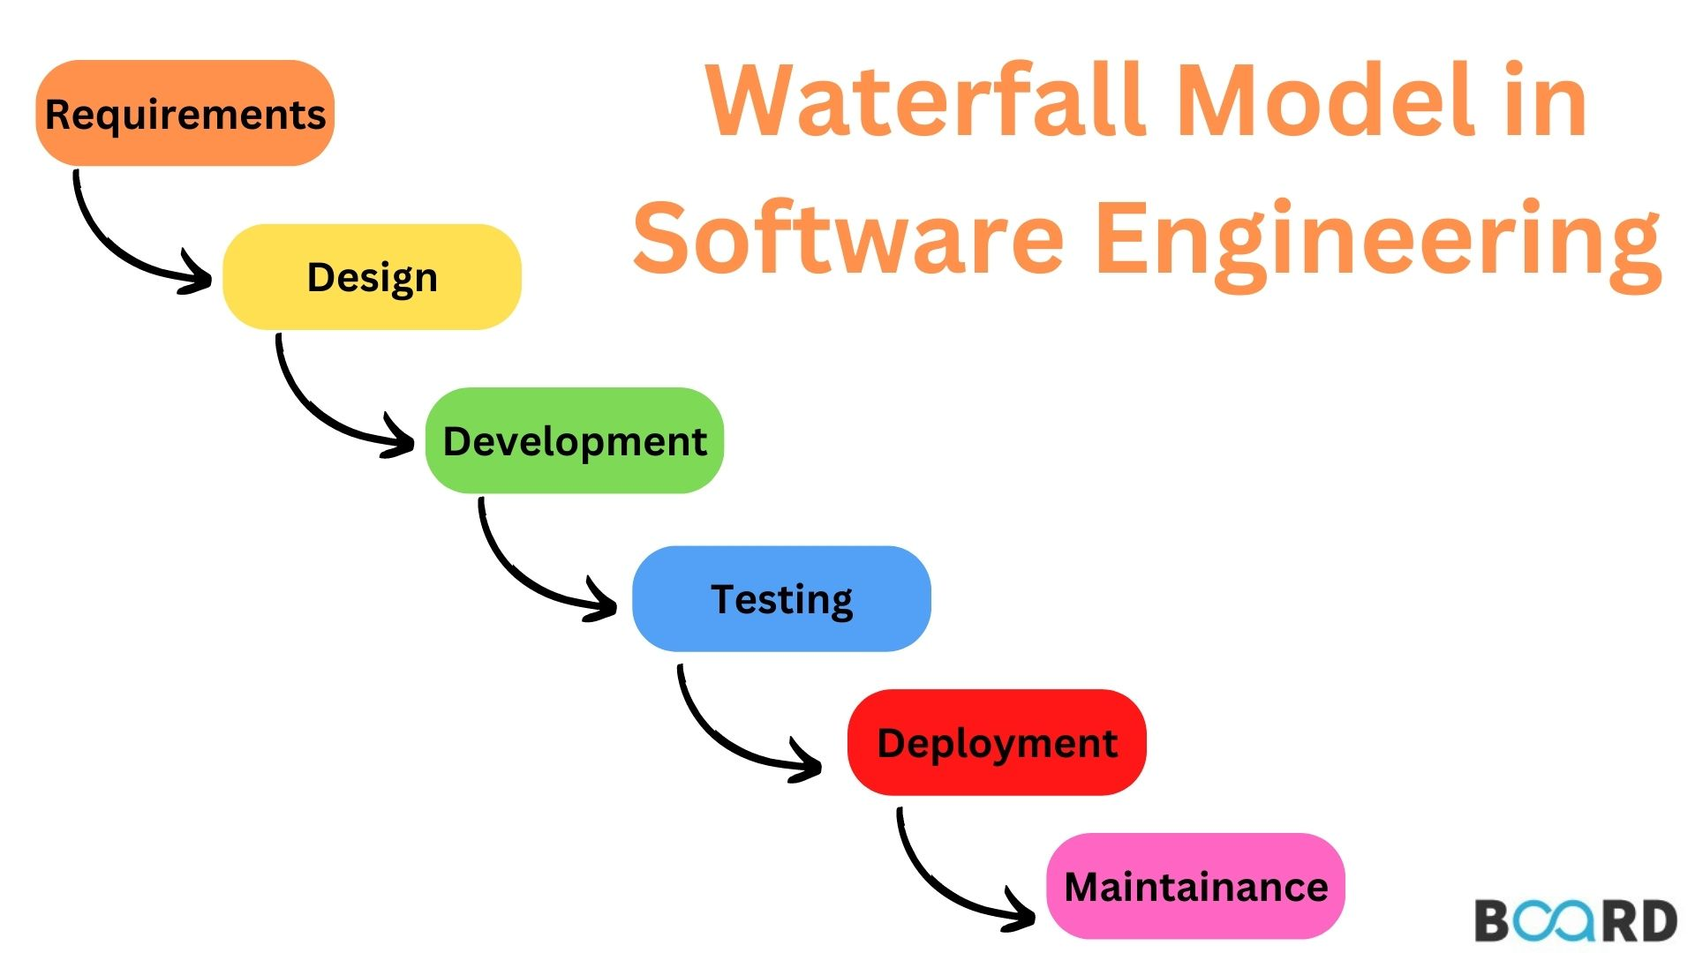

4.2.2 Deployment Model

* refers to the way software applications are released and made available to users. Common deployment models include on-premises, cloud, hybrid, container, serverless, and edge deployments, each with unique characteristics and benefits. The choice of model depends on factors like application nature, scalability needs, budget, security, and infrastructure capabilities.

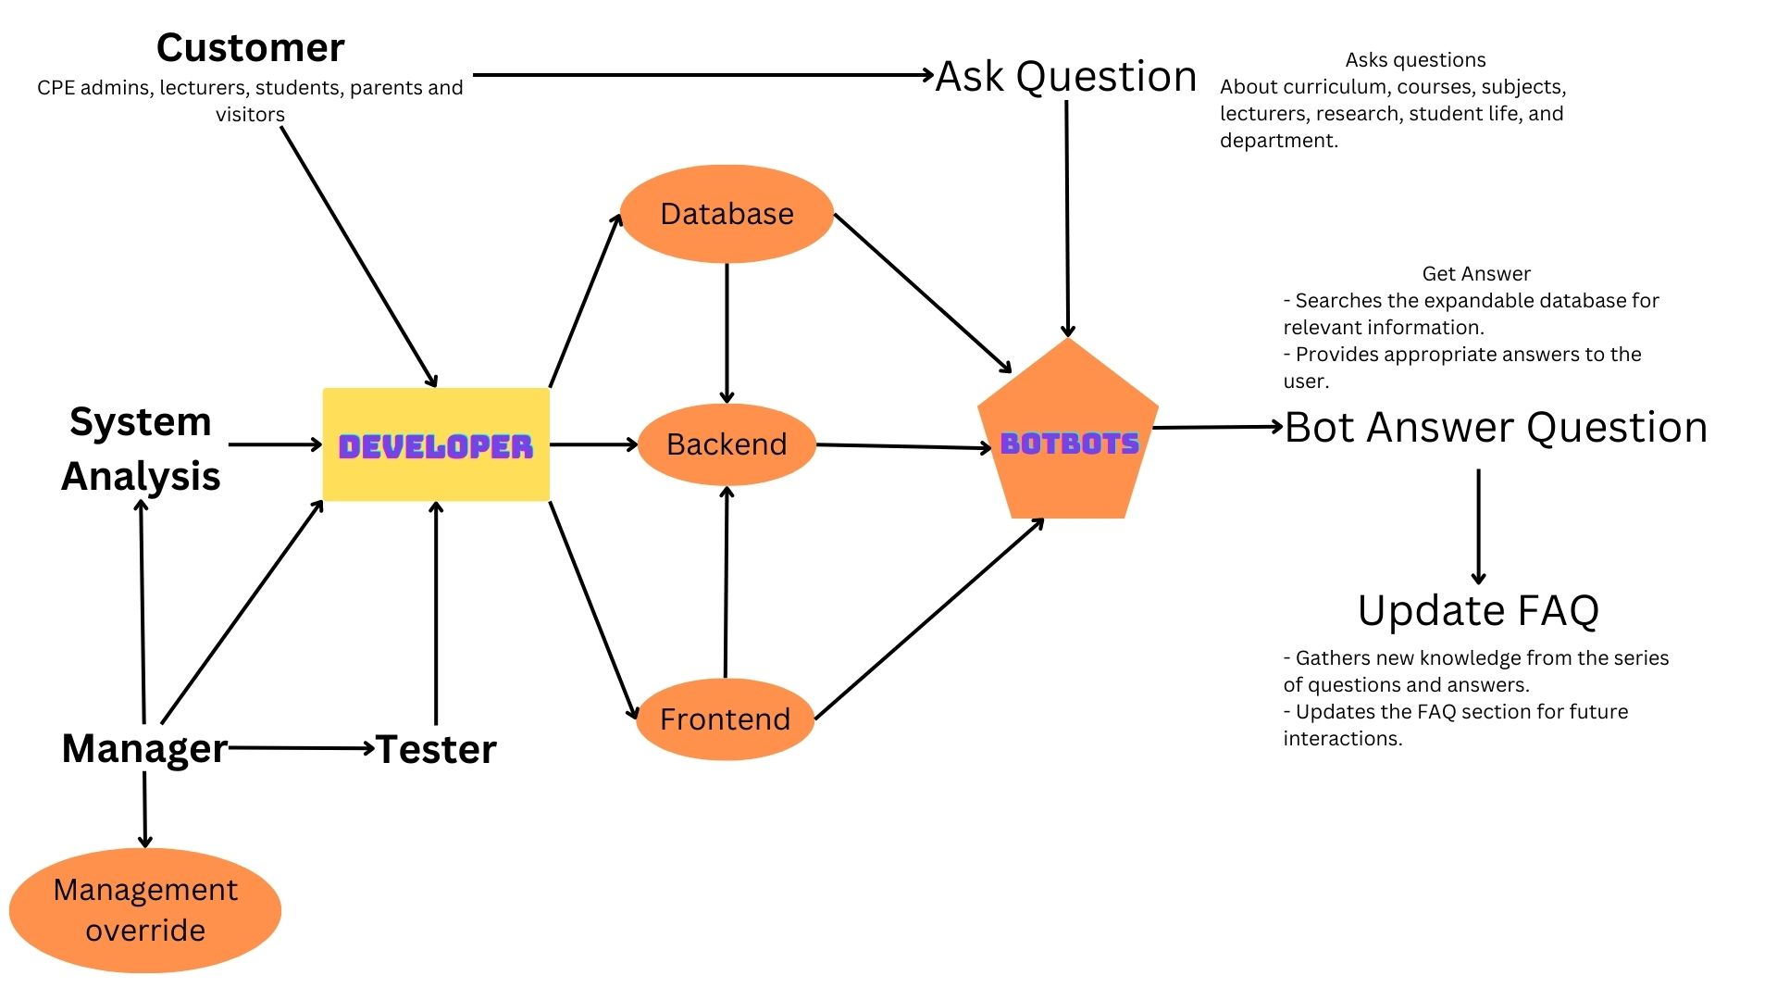

## 4.3 Appendix C: To Be Determined List

4.3.1 User Class management System

* User Interface for Student, Visitors, CPE Administrators, Lecturers, Parents
* Log in page

## 4.4 A1 - Responsibility

4.4.1 NUTTAPONG INKAEO 630615021 (8.33%)

* Meeting with Client (Discord Application, 17 July 2023)
* Specific Requirements

4.4.2 CHAYUT RIANPRAKAISANG 640615011 (8.33%)

* Meeting with Client (Discord Application, 17 July 2023)
* Specific Requirements

4.4.3 CHINNAWAT SERMSUKRUNGSAKUN 640615012 (25%)

* Meeting with Client (Discord Application, 17 July 2023)
* Appendix Section

4.4.4 NATAKORN THAMMATIWAT 640615013 (25%)

* Meeting with Client (Discord Application, 17 July 2023)
* Introduction Section

4.4.5 PARIPAT YUANSEE 640615019 (25%)

* Meeting with Client (Discord Application, 17 July 2023)
* Overall Description Section
* Table Of Content

4.4.6 HANCHUN WANG 640615504 (8.33%)

* Meeting with Client (Discord Application, 17 July 2023)
* Specific Requirements

## 4.5 A2 - Responsibility percentage calculation

4.5.1 Activities that not directly contribute to the document.

* Meeting with Client (Discord Application, 17 July 2023)
* Provide supporting information for SRS

4.5.2 Activities that directly contribute to the document.

* Document Setup (0%)
* Cover Page (0%)
* Introduction Section (25%)
* Overall Description Section (25%)
* Specific Requirements Section (25%)
* Appendix Section (25%)